**OUTPUTS OF RETRIEVING THE PRODUCT DETAILS USING THE PRODUCT ID**

1. index.html where the user is asked to enter the product id.

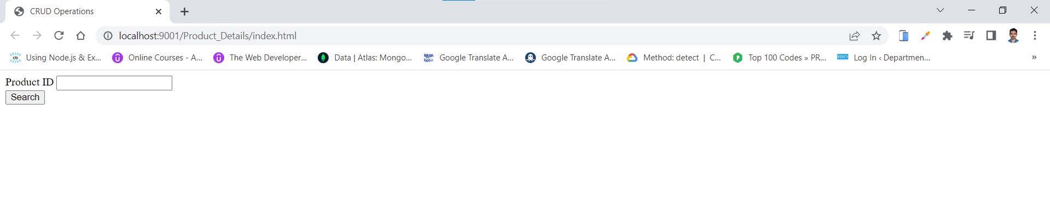

2. User enters product id and click on search button.

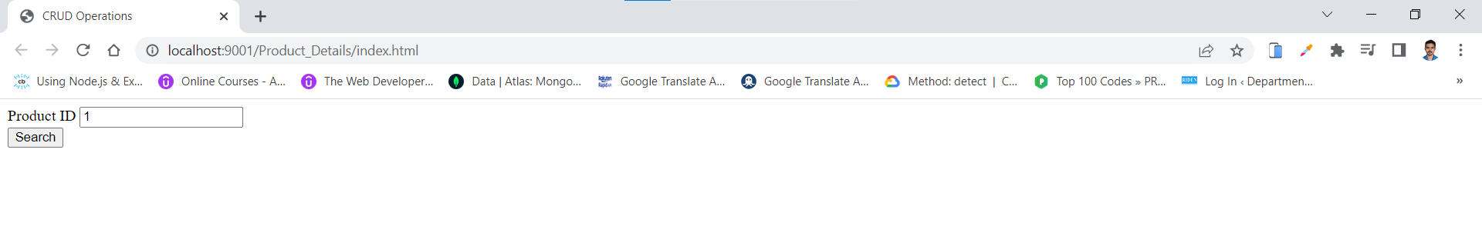

3. If a product with the product id exists in the database.

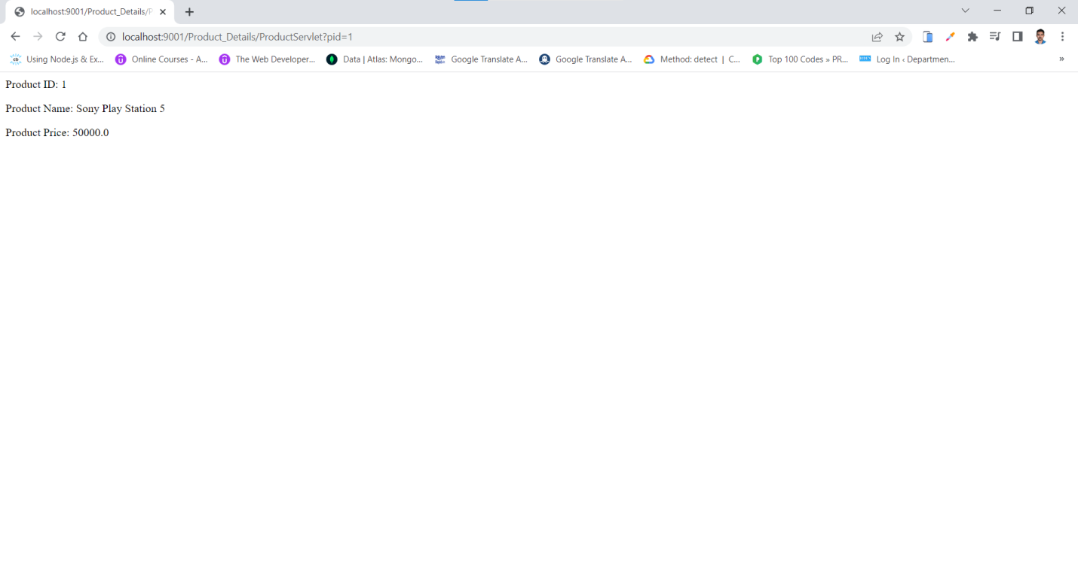

4. If a product with the product id does not exist in the database.

